Course : DBAS 21798

Assignment #5: MongoDB, NoSQL  
  
Manmeet

991667681

Q1. Create building collection based on the below description and insert few documents in it

* Building has id name and height
* Reference multiple room ids to a building (building has multiple rooms)
* Building has an embedded campus document. Campus has id and name.

Q2. Insert 3 rows each in all the collections. Display collections after insert is completed.

Q3. Create the below collection and make the following updates:

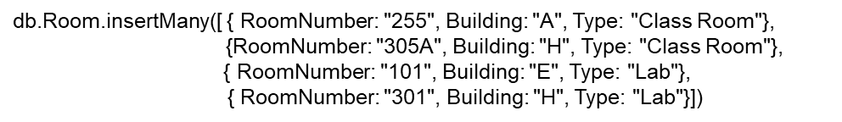

* Change the type of room 301 in building H to Office
* Change the name of building H to F
* Add a new field “capacity” and set it to 45 to all the Class Rooms.  
  
  
  
  
  
  
  
  
  
  
